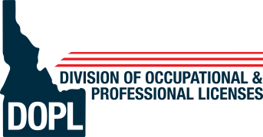 | State of Idaho  Division of Occupational and Professional Licenses Health Professions Bureau
BRAD LITTLE  Governor  RUSSELL BARRON  Administrator | 11341 W Chinden Blvd.  P.O. Box 83720  Boise, ID 83720-0063  (208) 334-3233  dopl.idaho.gov

Public Hearing Minutes of 08/21/2024

Division Staff: | Nicki Chopski, PharmD, Health Professions Bureau Chief Russell Spencer, General Counsel  Susan Villanueva, Board Support Specialist
The meeting was called to order at 3:00 PM by Dr. Chopski.

Dr. Chopski stated that board staff would accept public comments on the following rule chapters.

Idaho State Board of Pharmacy – 24.36.01

Mark Johnston, CVS Health, thanked the Board for their hard work and stated that CVS Health had thoroughly reviewed the chapter, and had no suggested changes to the Board of Pharmacy's proposed rules.

Comments were again invited on the proposed rule chapter. No other public testimony was given.

The next Board meeting will be held on September 12, 2024.

Adjourn
There being no further business, the meeting was adjourned at 3:22 PM.

